Week 3 – Application Selection for Performance Testing
1. Application Selection and Workload Classification
Objective
The goal of this phase is to pick representative applications that create different kinds of system workloads, to measure the performance of the operating system under different conditions. The chosen applications are light, very popular, and perfect for being administered remotely through SSH on a headless Ubuntu Server.
All of them are reflecting real server loads and their performance testing is still controlled and repeatable.
Application Selection Matrix
Application | Workload Type | Description | Justification
stress-ng | CPU-intensive | Synthetic workload generator | Allows controlled CPU saturation and repeatable benchmarking
stress-ng | Memory-intensive | Memory allocation and pressure testing | Useful for analysing RAM usage and swap behaviour
fio | I/O-intensive | Disk read/write benchmarking | Industry-standard tool for storage performance testing
iperf3 | Network-intensive | Network throughput testing | Measures TCP/UDP performance between systems
nginx | Server application | Lightweight web server | Represents real-world server workloads with low overhead
This selection provides coverage of CPU, memory, disk, network, and service-level workloads.
2. Installation Documentation (SSH-Based Installation)
All the software will be installed on the Ubuntu Server machine through Secure Shell (SSH) from the personal computer. To maintain uniformity and integrity of the packages, installation will be done using the Advanced Package Tool (apt).
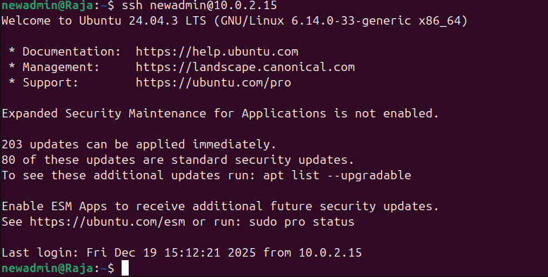
Package Update (Prerequisite)
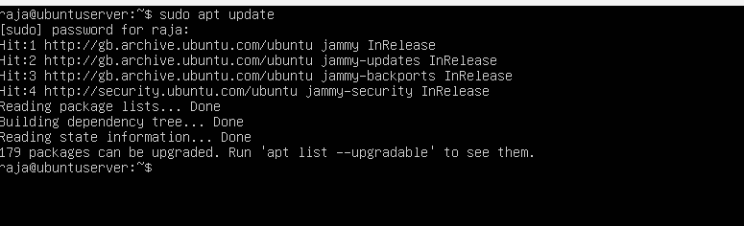
Application Installation Commands
Figure 1: stress-ng
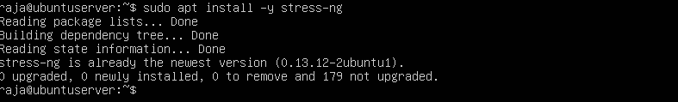
Figure 2: fio
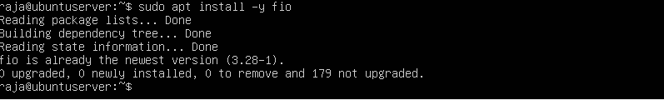
Figure 3: iperf3
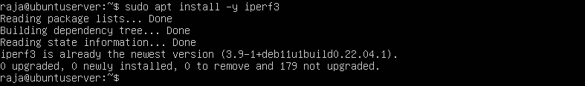
Figure 4: nginx
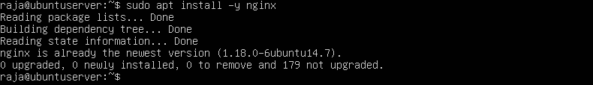
3. Expected Resource Profiles
Before the testing, expected resource consumption patterns were set up for each application. These anticipations serve as a benchmark for future performance assessment and verification.
Workload | Expected Resource Profile
CPU (stress-ng) | High CPU utilisation, minimal disk/network
Memory (stress-ng) | Progressive RAM allocation, swap usage possible
I/O (fio) | High disk throughput, minimal CPU load
Network (iperf3) | High sustained network traffic, minimal CPU/disk
Server (nginx) | Moderate CPU, low memory, consistent network

4. Monitoring Strategy
Monitoring Methodology
The system's actual monitoring will take place remotely by means of the command-line tools through SSH. A mixture of real-time and snapshot monitoring tools will be utilized for each kind of workload to monitor it.
Monitoring Tools per Application
Application | Metrics Observed | Monitoring Tools
stress-ng (CPU) | CPU load, load average | top, uptime, mpstat
stress-ng (Memory) | RAM and swap usage | free -h, vmstat
fio | Disk throughput and I/O wait | iostat, df -h
iperf3 | Network throughput | iperf3, ip -s link
nginx | Service performance | top, ss, curl

Evidence of Monitoring Capability
The following commands confirm that monitoring tools are available and functional on the server.
Figure 1: top
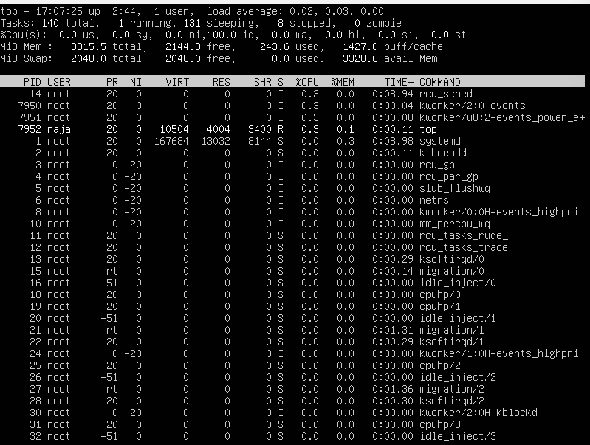
Figure 2: free -h
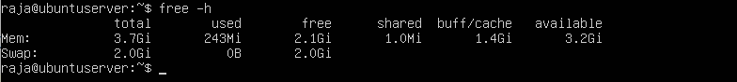
Figure 3: df -h
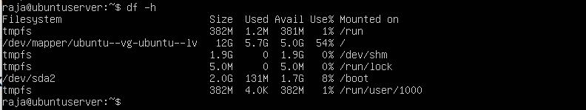
Conclusions
During the third week, applications considered to be representatives were chosen to produce different kinds of system loads for the purpose of performance testing. A matrix of application selection was created to support every decision through its type of workload and importance. All the installation steps were recorded with SSH-based command-line codes to guarantee that the process could be repeated and that it was compatible with remote admin. Moreover, the anticipated resource profiles were drawn up to aid subsequent analysis and the structured monitoring planned was to precisely record system activity during testing. The phase gets the environment ready for the performance evaluation and optimization process to take place systematically in the following weeks.

